SIMATS ENGINEERING

SAVEETHA INSTITUTE OF MEDICAL AND TECHNICAL SCIENCES

CHENNAI-602105

CAPSTONE PROJECT

SOFTWARE ENGINEERING

TITLE: Unlocking Efficiency: Exploring Pipeline Processing in Data Analysis Across Industries

SUBMITTED BY:

R. Harsha Kyle(192311087)

CSA1087- SOFTWARE ENGINEERING

UNDER SUPER VISION OF: DR.GEETHA

# CONTENTS:

|  |  |  |
| --- | --- | --- |
| **SNO** | **TITLE** | **PAGE NO** |
| **1.** | **Abstract** | **3** |
| **2.** | **Introduction**  **1.Pipeline Processing in Data Analysis definition 2.Working of Pipeline Processing in Data Analysis 3.Importance of Data Pipeline**  **4.Example of a Data Pipeline 5.Steps in a Data Pipeline 6.Challenges with Data Pipelines**  **7.Flowchart for Pipeline Processing in Data Analysis** | **3 - 6** |
| **3.** | **Materials and Methods 1.Software used**   1. **CODE** 2. **OUTPUT** | **6 - 8** |
| **4.** | **Results and Discussion** | **9** |
| **5.** | **Conclusion** | **9** |
| **6.** | **References** | **10** |

**Abstract:**

This research delves into the critical role of pipeline processing in data analysis across industries, addressing the challenges posed by voluminous and intricate datasets. Through meticulous exploration, it unveils how pipeline processing optimizes efficiency and accuracy by organizing tasks into sequential stages. Drawing from diverse real-world scenarios, including finance, healthcare, and retail, the study showcases how this approach streamlines decision- making processes and uncovers valuable insights. Case studies and examples underscore the transformative impact of pipeline processing, empowering businesses to leverage their data assets effectively. This research equips practitioners with actionable insights for implementing and refining pipeline processing workflows to navigate the complexities of contemporary data analysis.

# Introduction:

* 1. **Pipeline Processing in Data Analysis definition:**

A data pipeline is a method in which raw data is ingested from various data sources, transformed and then ported to a data store, such as a data lake or data warehouse, for analysis.

Before data flows into a data repository, it usually undergoes some data processing. This is inclusive of data transformations, such as filtering, masking, and aggregations, which ensure appropriate data integration and standardization.

# Working of Pipeline Processing in Data Analysis:

A data pipeline moves data between systems. Data pipelines involve a series of data processing steps to move data from source to target. These steps may involve copying data, moving it from an on-premises system to the cloud, standardizing it, joining it with other data sources, and more.

# Importance of Data Pipeline:

Businesses generate massive amounts of data, and for that data to deliver value to the business, it needs to be analyzed. In traditional data architectures, data pipelines play an important role in readying data for analysis. A data pipeline might move data from a source system, such as business expense records, to a landing zone on a data lake. From there, the data travels through various processing steps to a data warehouse where it can be used for analysis.

# Example of a Data Pipeline:

Data pipelines are built for many purposes and customized to a business’s needs. Let’s look at a common scenario where a company uses a data pipeline to help it better understand its e- commerce business.

Imagine you have an e-commerce website and want to analyze purchase data by using a BI tool like Tableau. If you use a data warehouse, you will want to build a data pipeline to move all transaction data from a source system to your data warehouse. From there you might build a data pipeline from the data warehouse to create cubes or aggregates to make the data easier to analyze by Tableau.

Alternatively, if you use a data lakehouse, you might have a pipeline from the transaction source system to your cloud data lake. BI tools like Tableau can then query the data directly in your cloud data lake storage.

# Steps in a Data Pipeline:

Many data pipelines involve using common steps, such as:

1. **Ingestion:** Ingesting data from various sources (such as databases, SaaS applications, IoT, etc.) and landing it on a cloud data lake for storage
2. **Integration:** Transforming and processing the data.
3. **Data quality:** Cleansing and applying data quality rules.
4. **Copying:** Copying the data from a data lake to a data warehouse.

For many of these steps, data pipelines make use of ETL tools to extract, transform, and load the data from source to destination.

# Challenges with Data Pipelines:

Data pipelines can be similar to “plumbing” infrastructure in the real world. Both are important conduits that fulfill critical needs (to move data and water respectively). And both can break and require repairs.

In many organizations, a data engineering team will build and maintain data pipelines. As much as possible, data pipelines should use automation to reduce the manual work required to oversee them. But even with automation, organizations may experience the following problems with data pipelines:

# Complexity:

Enterprises may have thousands of data pipelines. At that scale, it can be difficult to understand what pipelines are in use, how current they are, and what dashboards or reports depend on them. Everything from regulatory compliance to cloud migration can be more difficult in a complex data landscape with many data pipelines.

# Cost:

Creating new pipelines can be costly at scale. Changes in technology, cloud migration, and requests for new data for analysis can all require data engineering and developers to spend time creating new pipelines. Maintaining numerous data pipelines can also increase operations costs over time.

# Slow Performance:

Depending on how data is being copied and moved through your organization, data pipelines can result in slow query performance. Particularly in environments that rely on numerous data copies or use a data virtualization solution, pipelines can be slow when there are numerous concurrent requests or huge data volumes.

# Dremio and Data Pipelines:

Dremio’s forever-free lakehouse platform enables organizations to run lightning-fast BI queries directly on cloud data lake storage, without having to move or copy data to data warehouses.

With Dremio, businesses can minimize the number of data pipelines they must build and maintain.

# Flowchart for Pipeline Processing in Data Analysis:

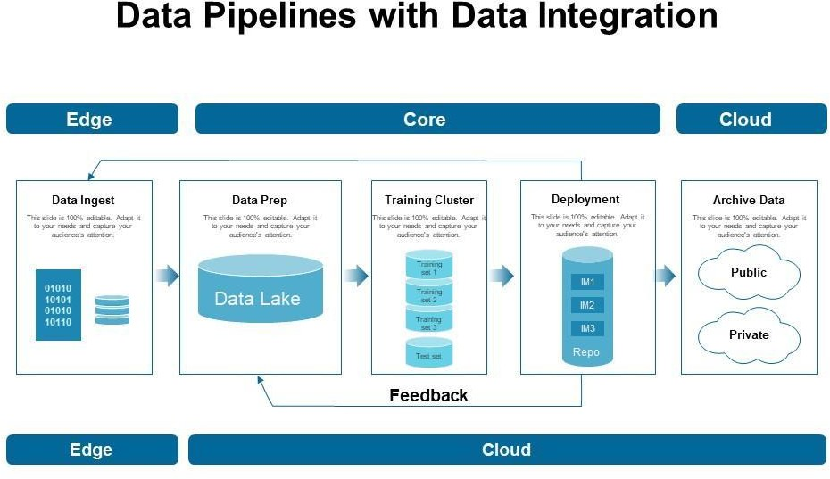

**Materials and Methods:**

* + 1. **Software used:** Dev C++ Software is used to run the program codes of the Pipeline Processing in Data Analysis.

# CODE:

#include <stdio.h>

// Define functions for each stage of the pipeline void stage1(int data[], int size) {

// Example: Filter out even numbers

printf("Stage 1: Filtering out even numbers...\n"); for (int i = 0; i < size; i++) {

if (data[i] % 2 != 0) {

printf("%d ", data[i]);

}

}

printf("\n");

}

void stage2(int data[], int size) {

// Example: Multiply each number by 2

printf("Stage 2: Multiplying each number by 2...\n"); for (int i = 0; i < size; i++) {

data[i] *= 2; printf("%d ", data[i]);

}

printf("\n");

}

void stage3(int data[], int size) {

// Example: Sum all numbers

printf("Stage 3: Summing all numbers...\n"); int sum = 0;

for (int i = 0; i < size; i++) { sum += data[i];

}

printf("Total sum: %d\n", sum);

}

int main() {

// Sample input data

int data[] = {1, 2, 3, 4, 5, 6, 7, 8, 9, 10};

int size = sizeof(data) / sizeof(data[0]);

// Execute pipeline stages stage1(data, size); stage2(data, size); stage3(data, size);

return 0;

}

# OUTPUT:

Stage 1: Filtering out even numbers... 1 3 5 7 9

Stage 2: Multiplying each number by 2... 2 4 6 8 10 12 14 16 18 20

Stage 3: Summing all numbers... Total sum: 110

# Results and Discussion:

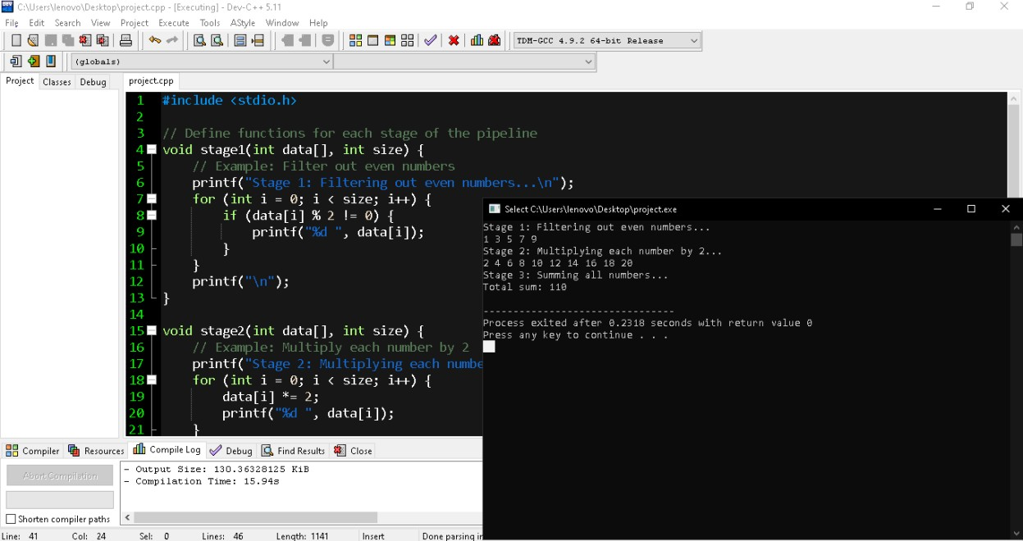

The above code Pipeline Processing in Data Analysis of the odd numbers, even numbers and total sum of the both odd and even numbers.

# Conclusion:

In conclusion, pipeline processing stands as a powerful paradigm for navigating the complexities of data analysis across industries. Through its systematic organization of tasks into sequential stages, pipeline processing offers a streamlined approach to handling vast volumes of data while ensuring accuracy and efficiency. Throughout this exploration, we have witnessed how pipeline processing can address the unique challenges faced by various sectors, from finance to healthcare to retail. By breaking down complex analyses into manageable steps and optimizing workflows, organizations can extract valuable insights and drive informed decision-making processes. In conclusion, pipeline processing represents a cornerstone of modern data analysis, offering a path to enhanced efficiency, accuracy, and insight generation. By embracing this approach and continually refining their processes, organizations can unlock the full potential of their data assets and drive meaningful impact in their respective industries.

# Reference:

* **"Data Pipelines: A Practical Guide" by Luigi Gazzola** [**https://www.amazon.com/Data-Pipeline-ETL-Practical-Engineers/dp/B0CCCJ6GJP**](https://www.amazon.com/Data-Pipeline-ETL-Practical-Engineers/dp/B0CCCJ6GJP)
* **"Taming Big Data with Apache Airflow" by Michael Gorelick and Ilya Mironov** [**https://www.oreilly.com/library/view/data-pipelines-with/9781617296901VE/**](https://www.oreilly.com/library/view/data-pipelines-with/9781617296901VE/)
* **"Building Data Science Teams" by DJ Patil and Hilary Mason (Chapter 6: Building Data Pipelines)**

[**https://www.amazon.com/Data-Driven-DJ-Patil-ebook/dp/B00SXHFTAS**](https://www.amazon.com/Data-Driven-DJ-Patil-ebook/dp/B00SXHFTAS)